Parameter-Efficient Fine-Tuning (PEFT) Techniques
The main techniques you should know are:
- Prompt Tuning
- Prefix Tuning
- P-Tuning
- LoRA
- AdaLoRA
- QLoRA
- Adapter Tuning
- BitFit
- IA³

1. Prompt Tuning

Basic idea
Instead of changing the model's millions or billions of parameters, we keep the model frozen and learn a small set of continuous prompt embeddings.

Traditional prompting
"Translate English to Telugu:
I am a student."
↓
LLM
↓
"నేను ఒక విద్యార్థిని."
With prompt tuning:
Learnable Soft Prompt
+
Input Text
↓
Frozen LLM
↓
Output
The prompt is not necessarily human-readable text. It consists of learnable vectors.

Example
Suppose the input is:
The movie was excellent.
A soft prompt might conceptually look like:
[P1] [P2] [P3] [P4] The movie was excellent.
P1...P4 are trainable embeddings.
The LLM parameters remain frozen.

Advantages
- Very few parameters are trained.
- Low storage requirements.
- Useful for adapting large language models to multiple tasks.

Limitation
Prompt tuning can sometimes be less effective than techniques such as LoRA for complex domain adaptation.

2. Prefix Tuning
Prefix tuning is related to prompt tuning but works differently.
Instead of adding trainable embeddings only at the input, learnable prefix vectors are introduced into the Transformer layers.
Conceptually:
Input
↓
Transformer Layer 1
↑
Prefix

Transformer Layer 2
↑
Prefix

Transformer Layer 3
↑
Prefix
↓
Output
The original Transformer parameters remain frozen.

Main idea
Frozen LLM
+
Trainable Prefix Parameters
↓
Task-specific LLM

Difference from Prompt Tuning
Prompt Tuning | Prefix Tuning
Learns soft prompt embeddings | Learns prefix representations
Mainly associated with input-level prompting | Prefix information is injected into Transformer layers
Simpler concept | More deeply integrated with Transformer computation

3. P-Tuning
P-Tuning is another soft-prompt-based technique.
Instead of manually designing prompts such as:
Classify the sentiment:
The product is excellent.
P-Tuning learns prompt representations automatically.
Learnable Prompt
↓
Input
↓
Frozen LLM
↓
Prediction
The prompt parameters are optimized during training.

Example
For sentiment classification:
[P1] [P2] [P3]
The product is excellent.
↓
LLM
↓
Positive
The vectors [P1] [P2] [P3] are learned.

4. LoRA
This is the most important technique for understanding PEFT.
LoRA = Low-Rank Adaptation.
Instead of modifying the original weight matrix:
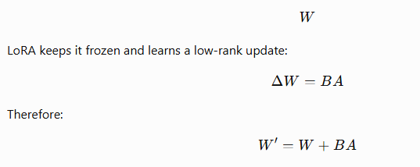
Input
│
┌───────┴────────┐
│ │
Frozen W LoRA A
│ ↓
│ LoRA B
│ │
└───────┬────────┘
↓
Output

Why low rank?

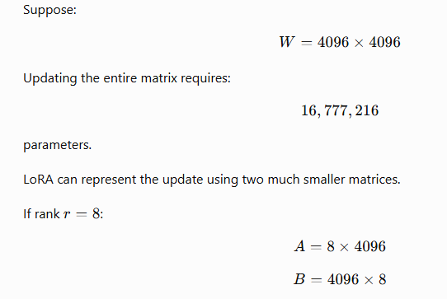

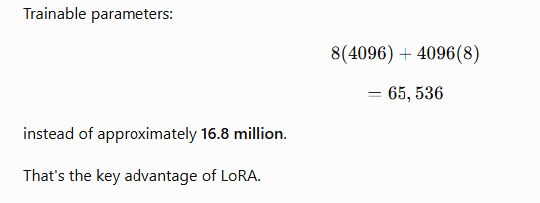

5. AdaLoRA
AdaLoRA = Adaptive LoRA.
It improves upon standard LoRA by dynamically allocating the parameter budget to different parts of the model.
Standard LoRA might use:
Layer 1 → rank 8
Layer 2 → rank 8
Layer 3 → rank 8
Layer 4 → rank 8
AdaLoRA can adapt the rank:
Layer 1 → rank 4
Layer 2 → rank 12
Layer 3 → rank 6
Layer 4 → rank 16
The idea is:
Give more trainable capacity to important layers and less to less-important layers.

Advantage
Better use of a fixed parameter budget.

6. QLoRA
QLoRA = Quantized LoRA.
QLoRA combines:
- Quantization
- LoRA
The base LLM is stored in a low-bit representation, commonly 4-bit, while LoRA adapters are trained.
Conceptually:
Large LLM
│
4-bit Quantization
│
Frozen Base Model
│
+ LoRA Adapter
│
Training
↓
Fine-tuned Model

Why is QLoRA important?
Large models require substantial GPU memory.
Quantization reduces the memory required to store the base model.
LoRA reduces the number of trainable parameters.
Therefore:

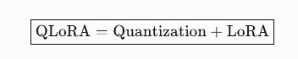

Enterprise significance
QLoRA can make adapting large models more feasible when GPU memory is limited.

7. Adapter Tuning
Adapter tuning inserts small neural-network modules called adapters into the existing Transformer architecture.
The original model is frozen.
Input
↓
Transformer
↓
Adapter
↓
Transformer
↓
Adapter
↓
Output
A simplified adapter can be represented as:
Input
↓
Down Projection
↓
Small Hidden Layer
↓
Up Projection
↓
Output
The adapter is much smaller than the original model.

Example
Base LLM
+
Legal Adapter
↓
Legal AI
Base LLM
+
Education Adapter
↓
Education AI
Base LLM
+
Finance Adapter
↓
Finance AI
This makes adapters useful for organizations supporting multiple domains.

8. BitFit
BitFit = Bias-Term Fine-Tuning.
This is an extremely simple PEFT method.
Instead of training all model weights, only the bias parameters are updated.
Model weights → FROZEN
Bias parameters → TRAINABLE

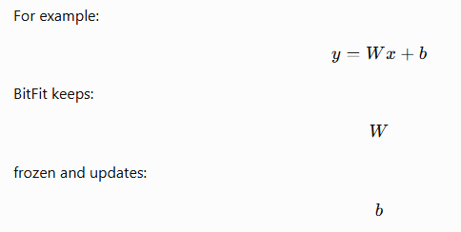

Advantage
Very few parameters need to be trained.

Disadvantage
It may not provide enough flexibility for complicated adaptation tasks.

9. IA³
IA³ is another parameter-efficient technique.
It modifies the behavior of the network using learnable scaling vectors rather than updating the complete weight matrices.
Conceptually:
Original activation
↓
Scaling Vector
↓
Modified activation
↓
Transformer
Only a small number of scaling parameters are trained.

Main advantage
Extremely parameter-efficient adaptation.

Comparison of PEFT Techniques
Technique | What is trained? | Main idea
Prompt Tuning | Soft prompt embeddings | Learn continuous prompts
Prefix Tuning | Prefix parameters | Add trainable prefixes to Transformer layers
P-Tuning | Learnable prompt representations | Automatically optimize prompts
LoRA | Low-rank matrices | Learn low-rank weight updates
AdaLoRA | Adaptive low-rank matrices | Allocate ranks dynamically
QLoRA | LoRA + quantized model | Reduce memory + train adapters
Adapter Tuning | Small adapter networks | Insert small trainable modules
BitFit | Bias parameters | Train only biases
IA³ | Scaling vectors | Scale internal activations

Full Fine-Tuning vs PEFT
This is an important 5-mark examination comparison.
Parameter | Full Fine-Tuning | PEFT
Base model | Updated | Usually frozen
Trainable parameters | Very high | Very low
GPU memory | High | Lower
Training cost | High | Lower
Training time | Long | Shorter
Storage | Large | Small
Multiple task models | Expensive | Easier
Deployment | More resource-intensive | More efficient
Domain adaptation | Powerful | Efficient
Enterprise suitability | Costly at scale | Generally attractive

Which PEFT Technique Should You Choose?
A simple decision guide:
Need to adapt an LLM?
│
▼
┌───────────────────┐
│ Very small change?│
└─────────┬─────────┘
│
Yes ───┴─── No
│ │
▼ ▼
Prompt Tuning LoRA
│
Memory constrained?
│
Yes ───┴─── No
│ │
▼ ▼
QLoRA LoRA

Need adaptive rank?
│
▼
AdaLoRA

Most Important Techniques for Your Course
For JNTUA Generative AI, I recommend students learn these particularly well:

⭐ Level 1 — Must Know
- Prompt Tuning
- LoRA
- QLoRA

⭐ Level 2 — Important
- Prefix Tuning
- P-Tuning
- Adapter Tuning

⭐ Level 3 — Advanced
- AdaLoRA
- BitFit
- IA³

